Azure Portal

Search: Create Web APP

Give subscription / Group of resources

**Instance Detail**

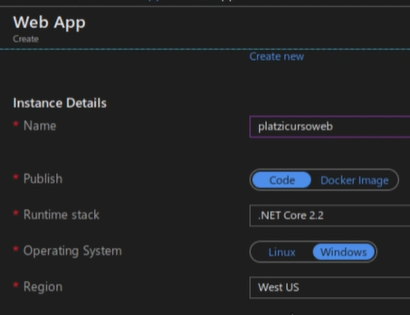

* The name of web app is going to be the URL
* Code, instead of docker image
* Select language
* Operating system
* Region

**App Service Plan**

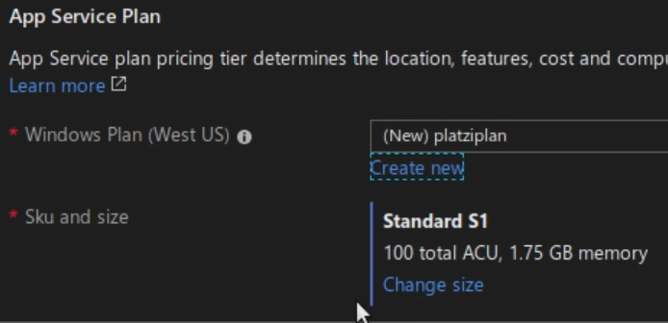

Select plan or create a new plan name

Change Size for RAM / Disc

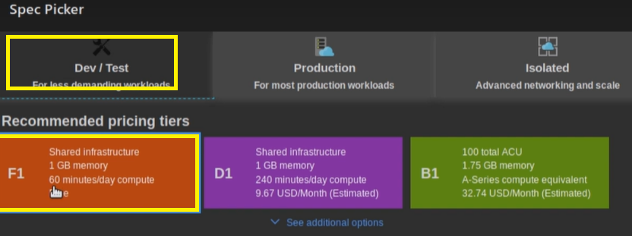

Review – Create

Create

Go to Resources

